Banking Tax Rules Sample Readme
This decision service shows how to leverage business rules project in the tax context for form validation, field validation and tax calculation.

Download and install
This project be downloaded individually. Import the project into Rule Designer:
Click File > Import > Expand General > Select Existing Projects into Workspace, and click Next. Browse to the downloaded project.

The purpose of the decision service is to determine the tax due. Input parameters are all based in XML Schemas, so the resulting decision service can be easily be called as a HTDS. This is the XOM being used by the rules:
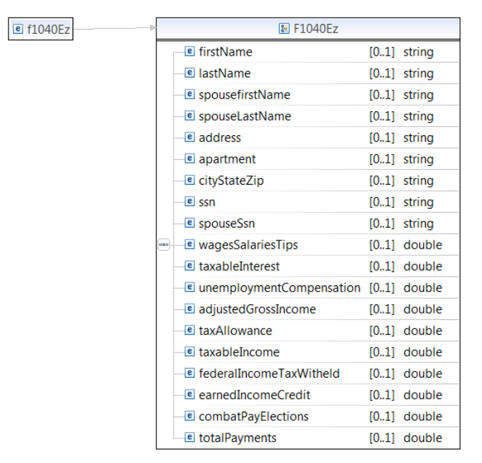
The above Schema is being used for input.
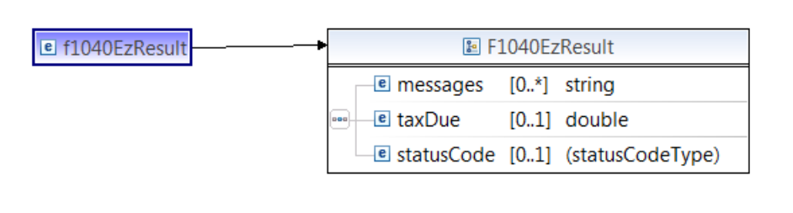
The above Schema is being used for output.

The overall process is as follows:
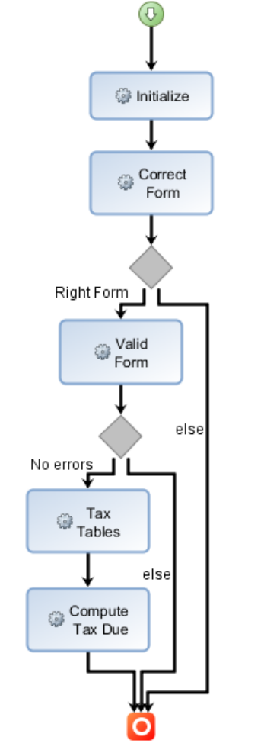

This decision service shows how to leverage business rule project in the tax context for form validation, field validation and tax calculation.

The rule artifacts includes
. taxation ruleflow
. simple form 1040 in XSD format
. 5 DVS test scenarios.
History changes
Version: 8.7.0 (Feb 19, 2015)
First version published to Bluemix DevOps
. migrated to 8.7 and new Decision Service
. removed xls format scenario

Version 8.6.0 - July 4, 2014
. First version shared.

